**Paper: Facebook Que2Search** **1**

**Paper: Extreme MultiLabel Learning For Semantic Matching in Product Search** **4**

Other Approachs 5

XMCS Model In More Details 6

**Paper: Bipartite Dynamic Representation for Abuse Detection** **9**

CHALLENGES 10

Their Approach 12

Architecture 13

How to Train 15

Evaluation 19

**TALK: Applied Data Science For Predictive Time Series Analytics** **23**

Abstract 23

Logistics 23

Slides 24

Background 26

Evaluation & BenchMark 27

Interactive and Expoloration Tools 29

**TALK: Knowledge Graph Completion From a Practical Perspective** **30**

Abstract 30

Logistics 30

Slides 30

This Talk: Task Graph Completion: Infer Missing Information 32

Evaluating Truthfulness of Embeddings 32

CodeX benchmark 41

Complemtary task: Locating Missing Information 44

# **Paper: Facebook Que2Search**

* Presenter: Yinqun Liu
* <https://dl.acm.org/doi/abs/10.1145/3447548.3467127>
* They use a two tower model based on query and document.

Content_feature: Tri-gram + transformer +



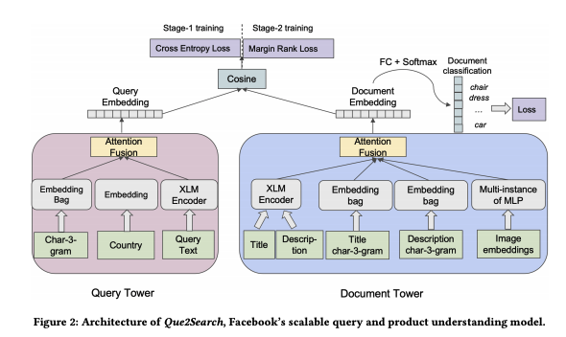

* They enhance deployment with token based filtering, to enable search
* Phrase as retrieval (two tower) + reranking (gbt)

‘

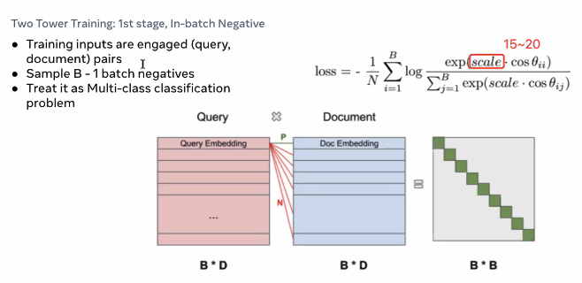

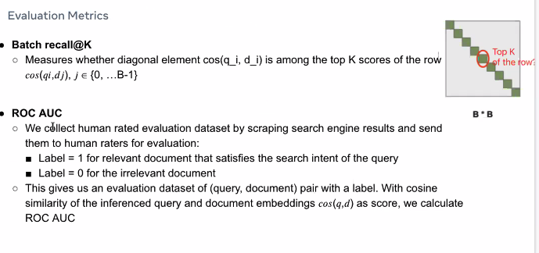

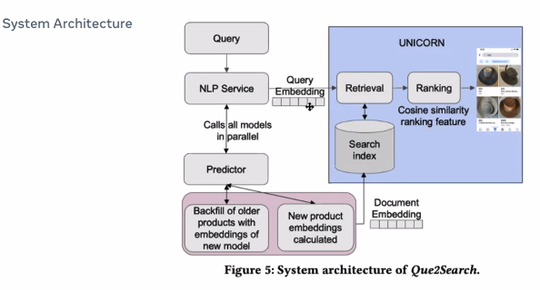

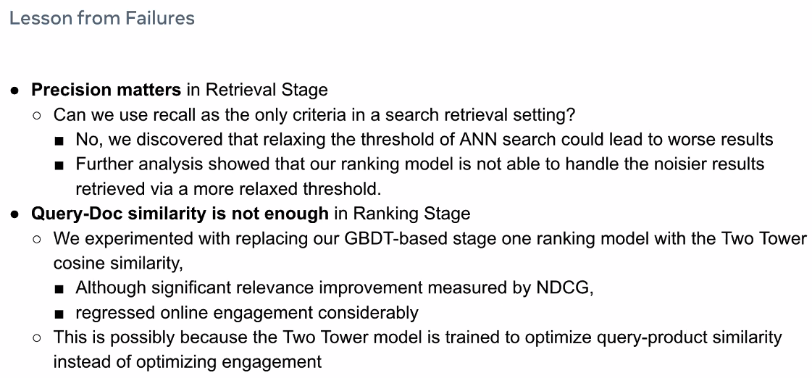

# 

# 

# **Paper: Extreme MultiLabel Learning For Semantic Matching in Product Search**

# 

Retrieval → Ranking

This talk is related to retrieval

### Other Approachs

### 

This is one approach:

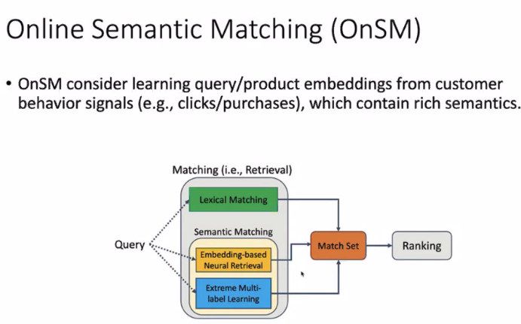

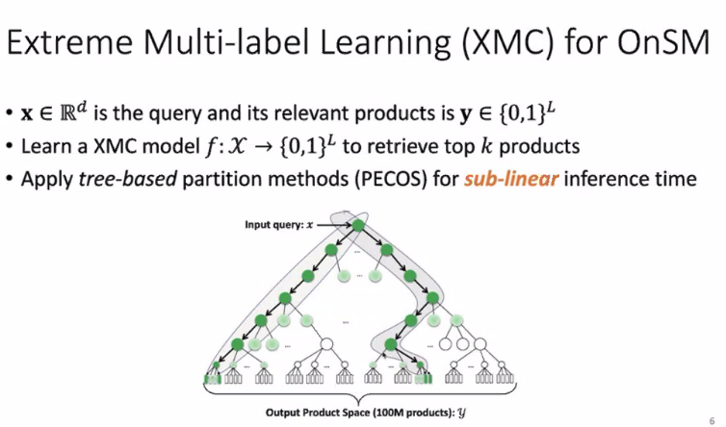

### XMCS Model In More Details

Leaf: product

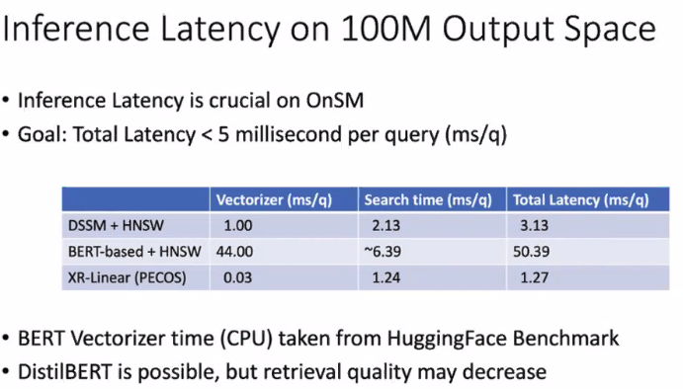 Latency < 5ms; 1.27ms!!!

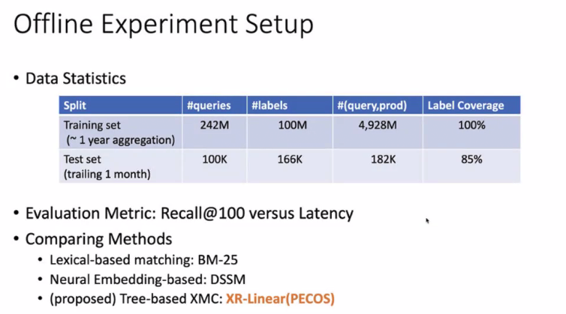

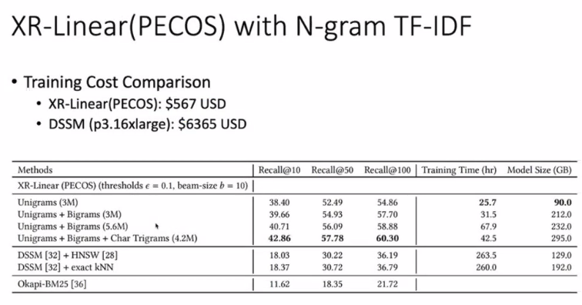

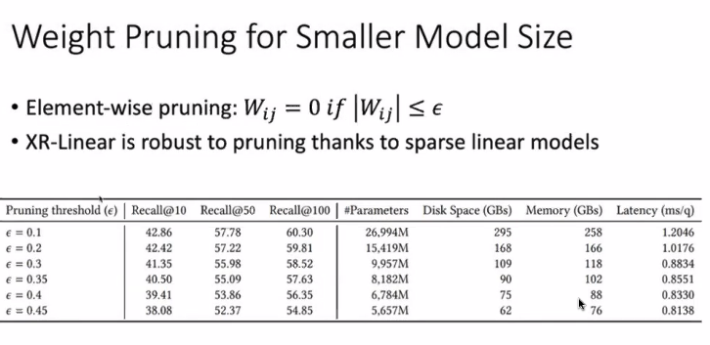

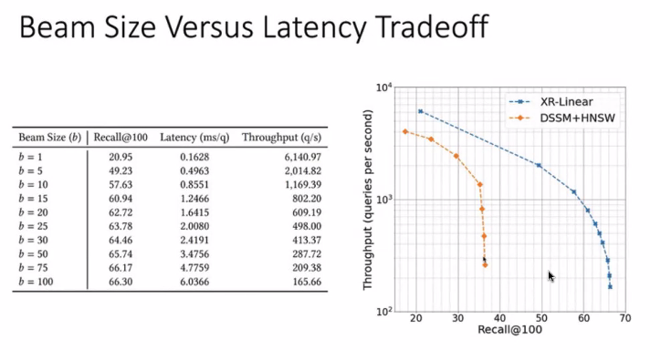

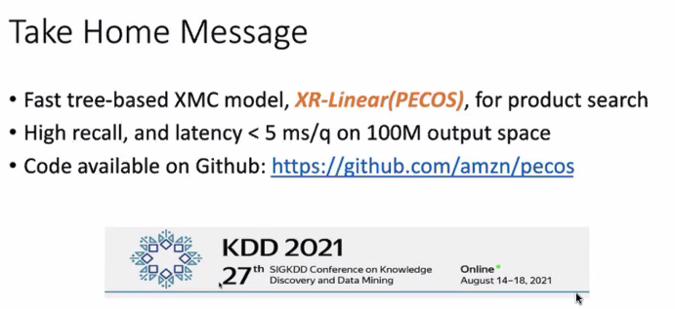

# **Paper: Bipartite Dynamic Representation for Abuse Detection**

Presenter: Andrew Wang, Stanford

Trust between users and product

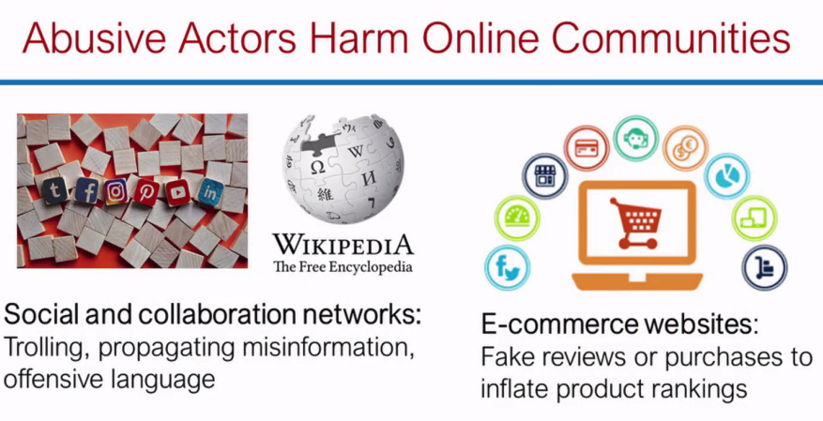

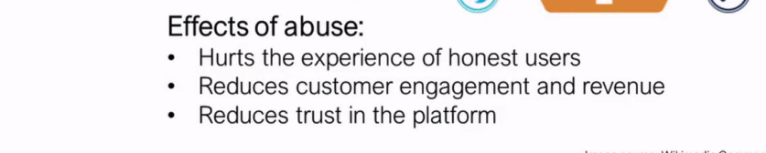

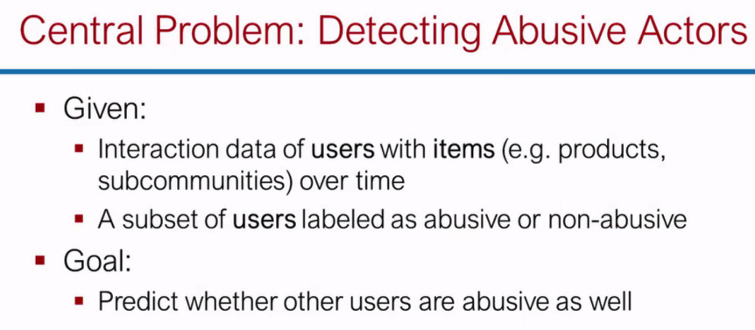

### CHALLENGES

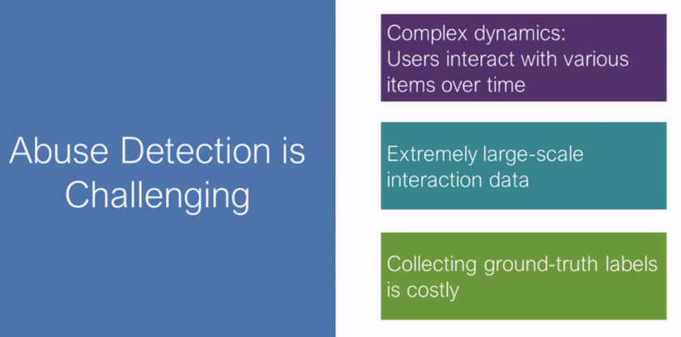

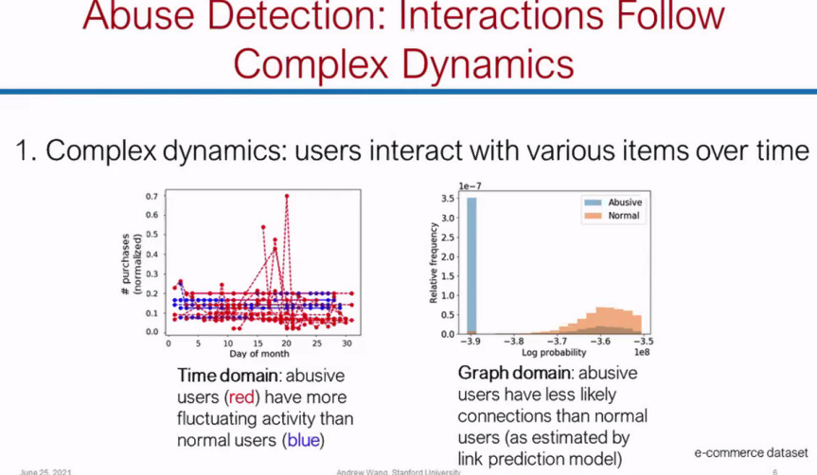

How do you model the user - item interaction

Inisghts

Red = abusive, abusive users are much more sporative

Edge = abusive users buy combination to products which are not common

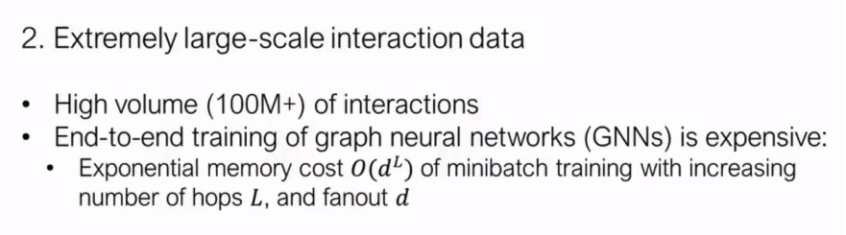

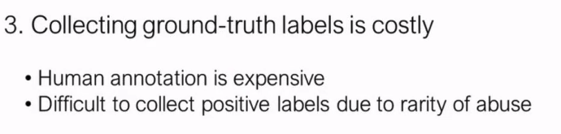

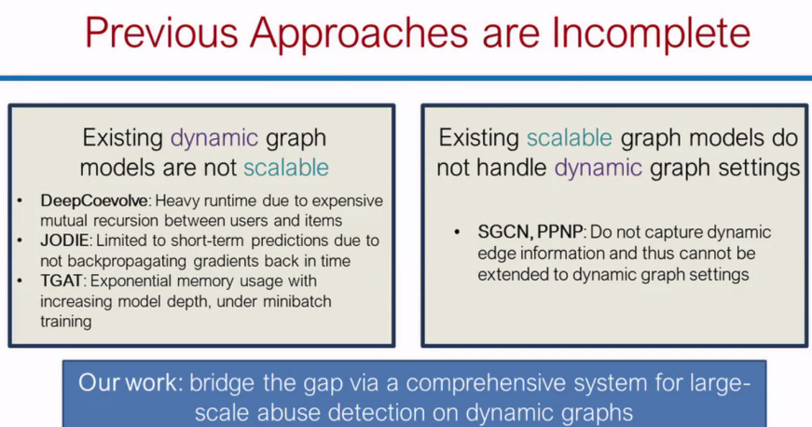

What is dynamic? Adding new nodes and edges over time..

### Their Approach

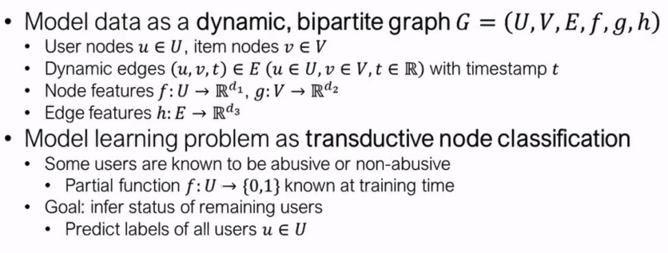

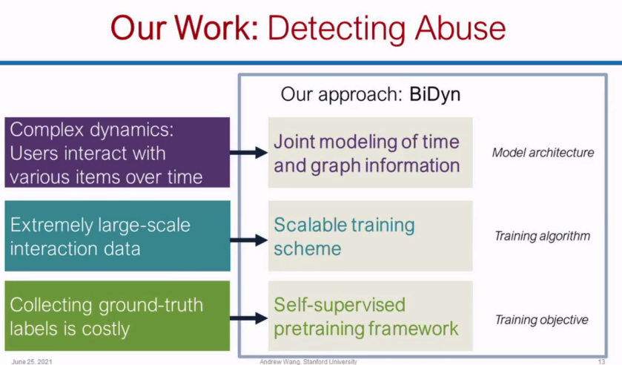

How their approach address these approaches

### Architecture

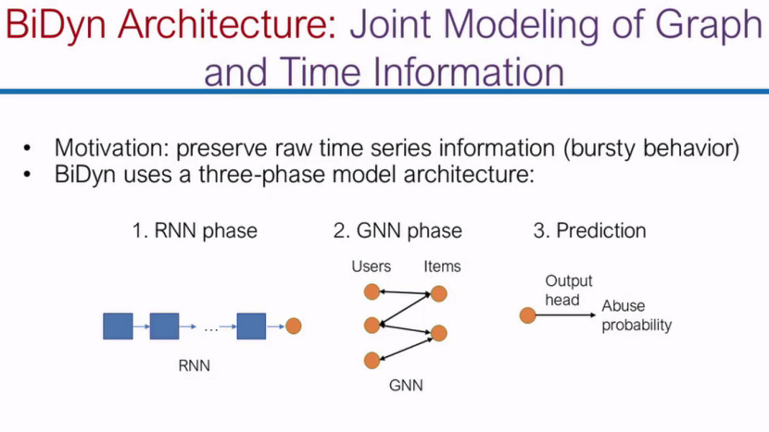

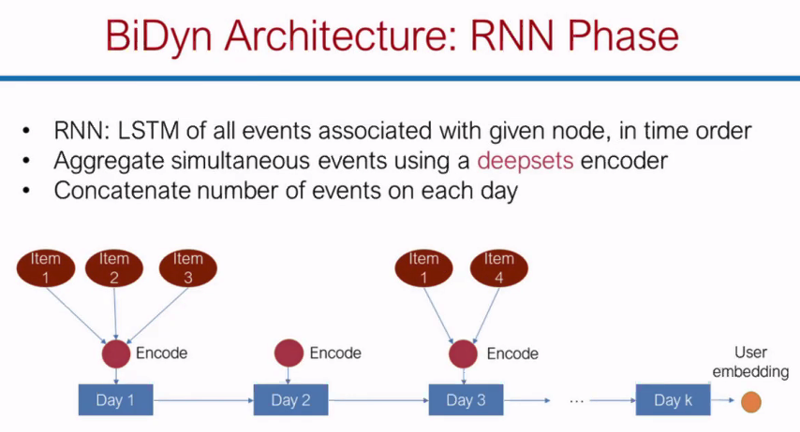

RNN give embedding for each node

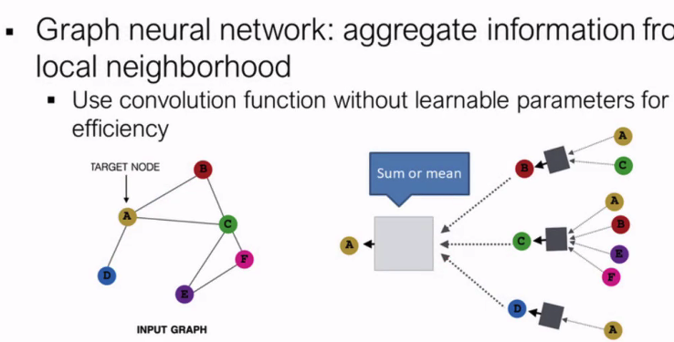

GNN propagate each node representon to its neightbor

Use sum or mean

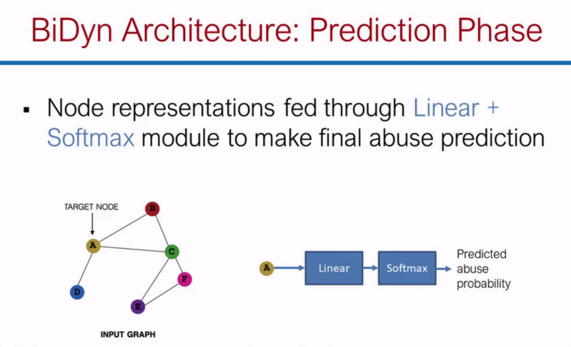

### How to Train

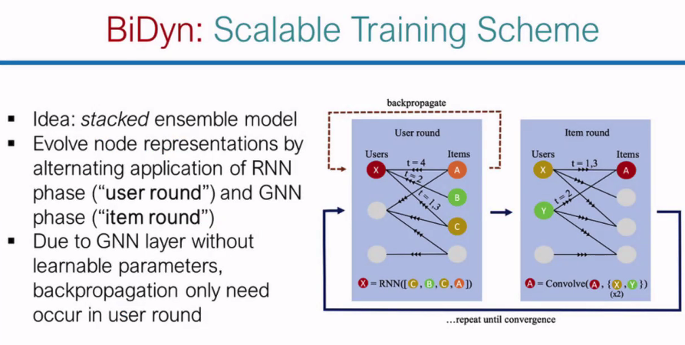

Back propagation only happers in user round

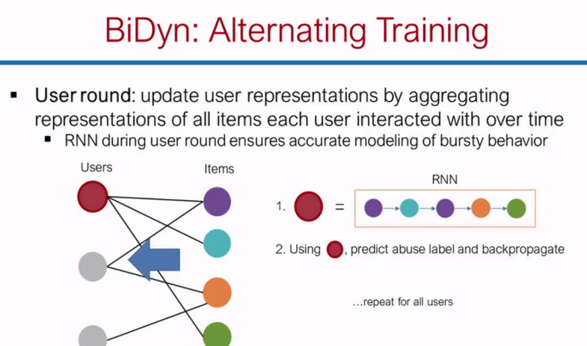

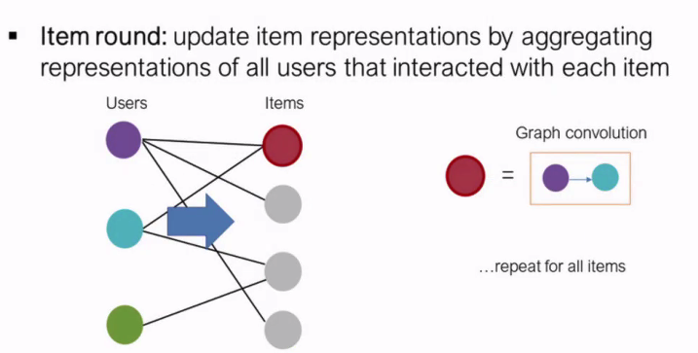

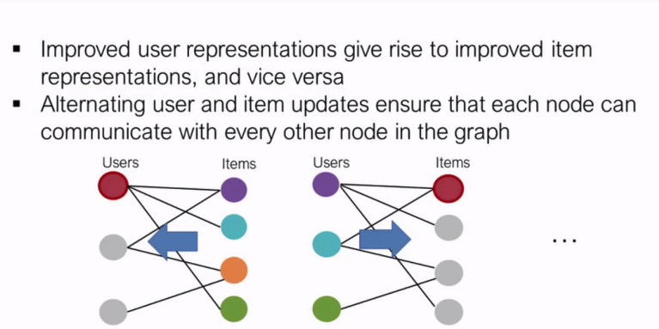

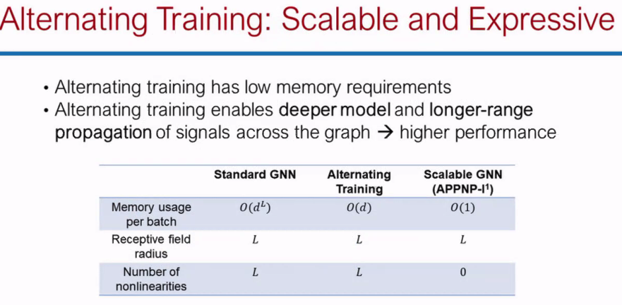

Compare to GNN, this approach has much less memory footprint

Coolecting Ground Labels

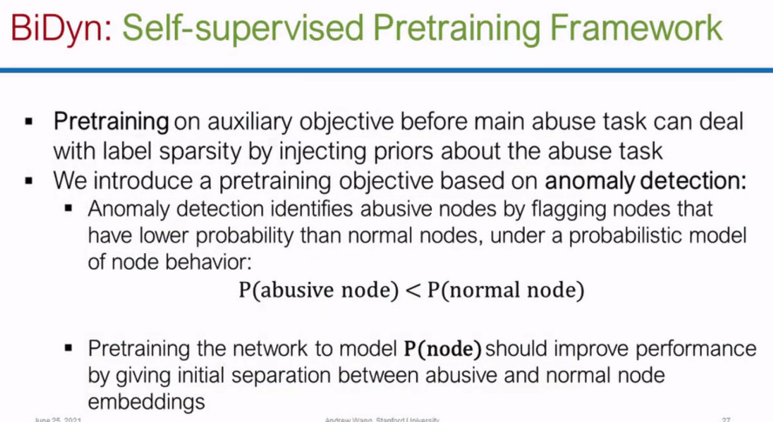

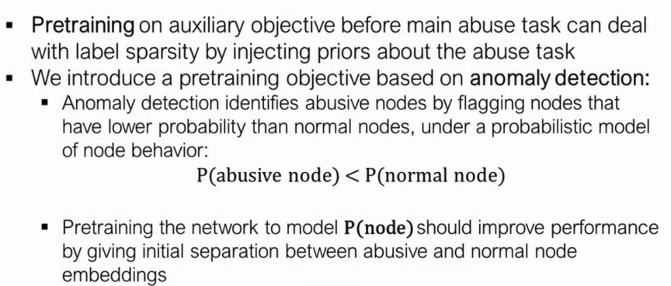

Unusual node has

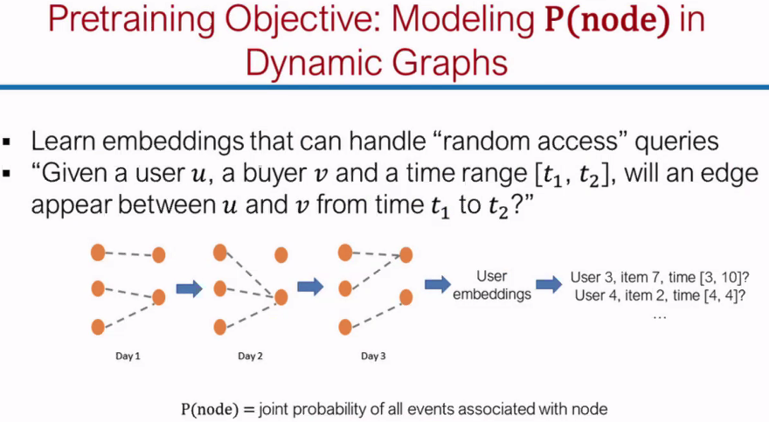

### Evaluation

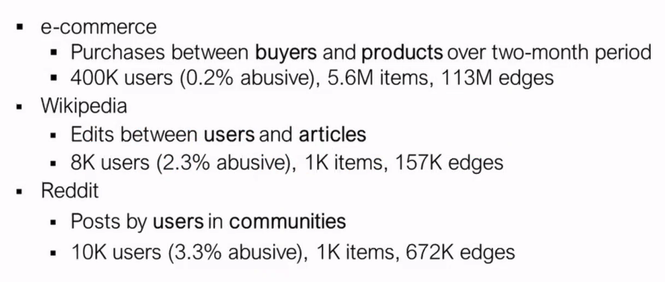

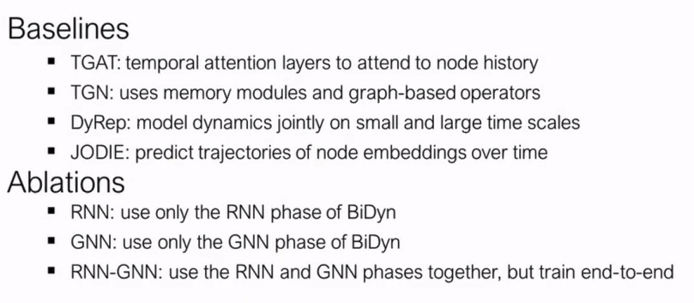

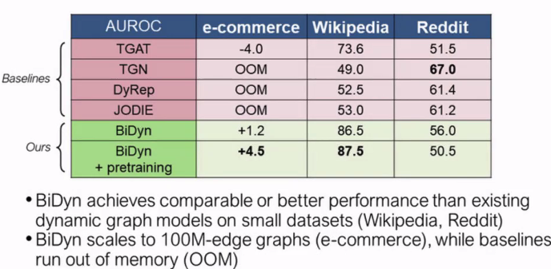

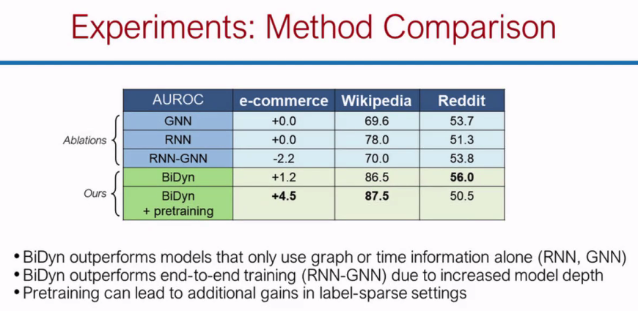

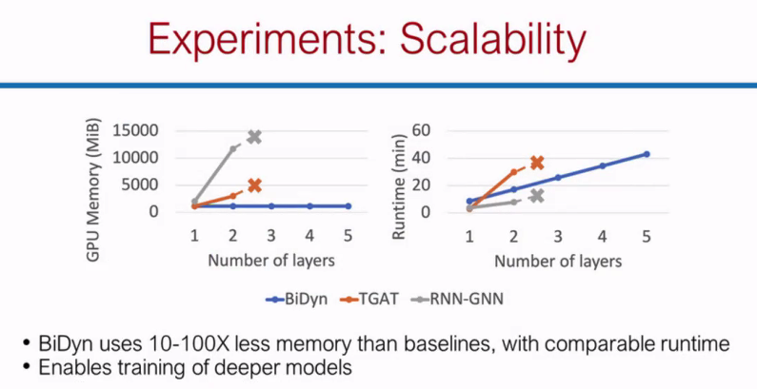

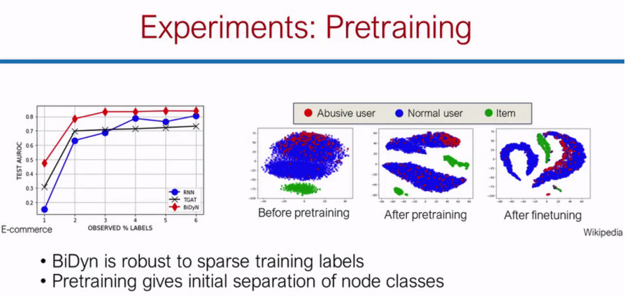

Pretraiing helps separate the clases

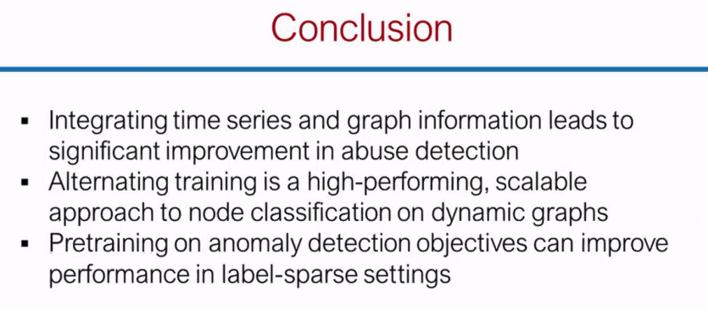

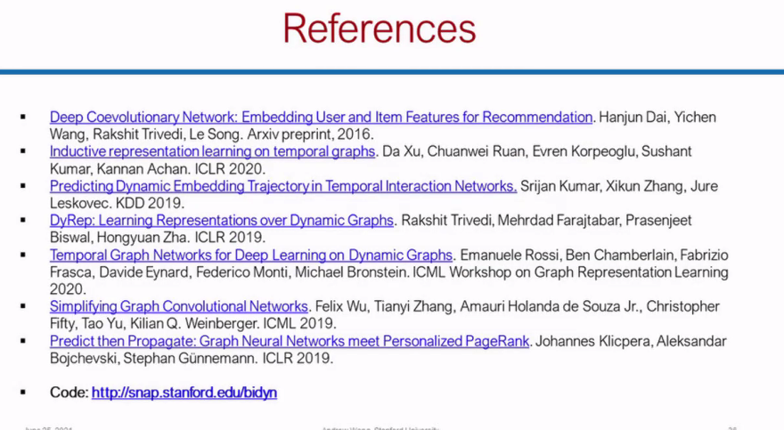

<https://snap.stanford.edu/bidyn/>

https://github.com/qema/bidyn

# **TALK: Applied Data Science For Predictive Time Series Analytics**

## Abstract

## Logistics

10:45-11:30 AM, Tuesday https://virtual.2021.kdd.org/plenary_session_invited_talk_by_Nesime_Tatbul.html

## Slides

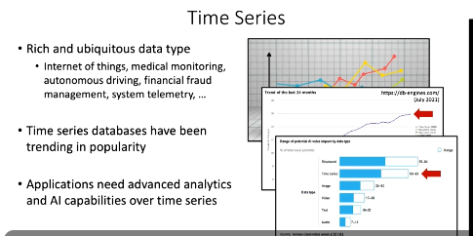

Application: Finance + IOT + Anomaly Detection

Case Study: Slack

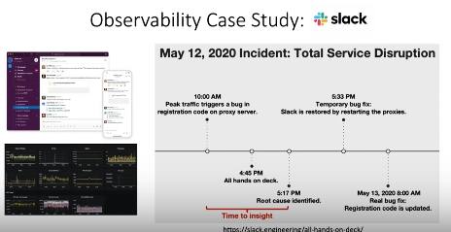

Reducing Time to Insight

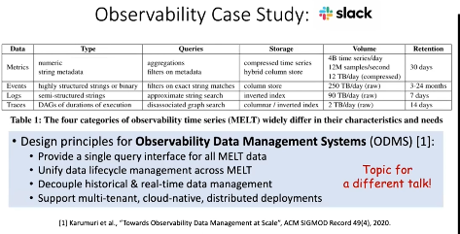

Time Series Challenges

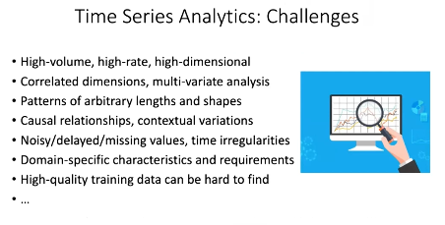

Ebay Search NRT DEBUG !!!

OverView:

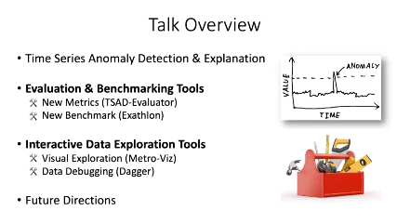

## Background

## 

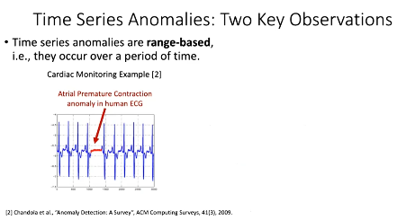

## 

## Evaluation & BenchMark

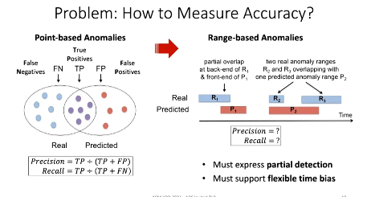

Precision Recall is not sufficient for Range based anamoly

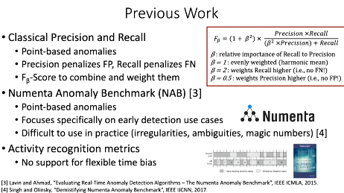

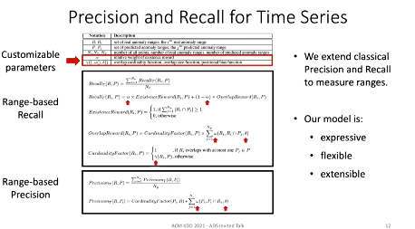

Their proposal; red is tunable parameters

Their proposal can become precision recall for a subset of parameter

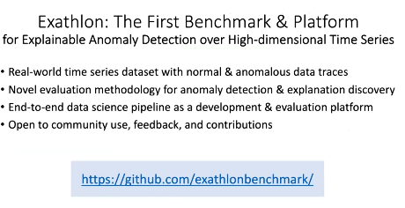

Code for this metric is shared in this github

Use Case:

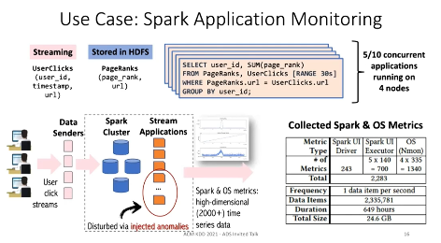

## Interactive and Expoloration Tools

**Research Paper:**

E-Commerce, Social Commerce D: 1PM - 2:30PM (A24)

Recommender Systems C : 1PM -2:30PM (A31)

# **TALK: Knowledge Graph Completion From a Practical Perspective**

## Abstract

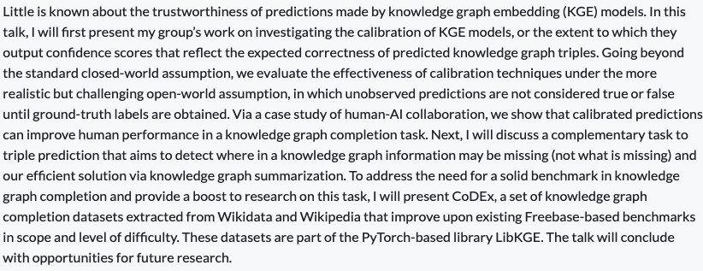

## Logistics

1:45-2:30 PM, Tu

https://virtual.2021.kdd.org/plenary_session_invited_talk_by_Danai_KOUTRA.html

## Slides

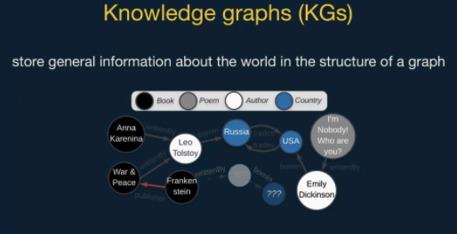

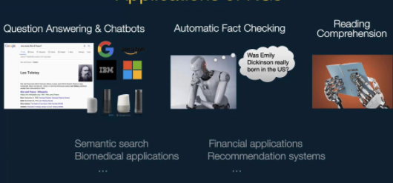

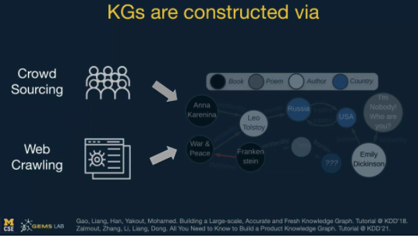

### This Talk: Task Graph Completion: Infer Missing Information

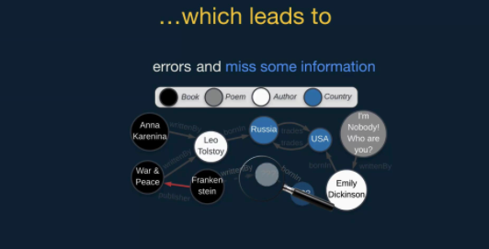

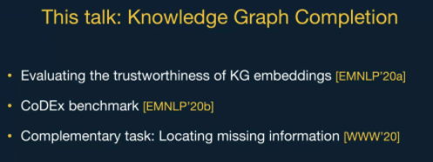

## Evaluating Truthfulness of Embeddings

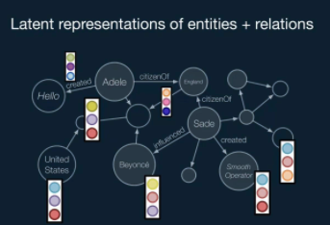

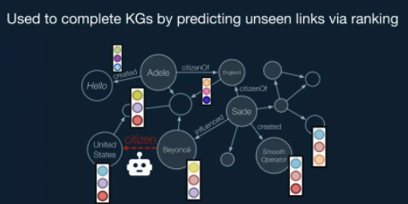

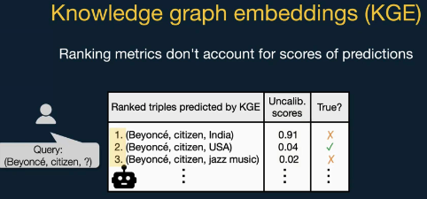

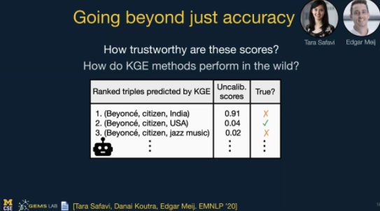

## 

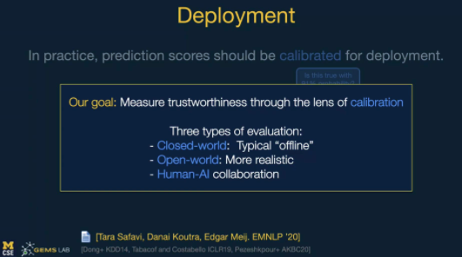

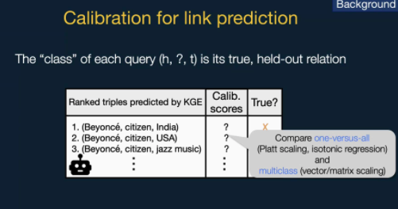

Post calibration is a post-proces, and do not need to update the embeddings

calibration types

One vs all:

softmax

Typically, we don’t have negative in graphs

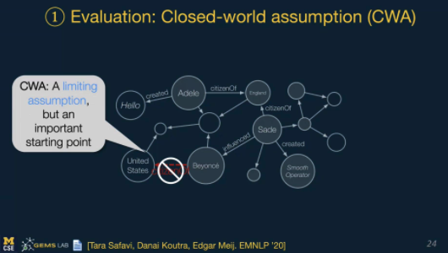

CWA = Class world

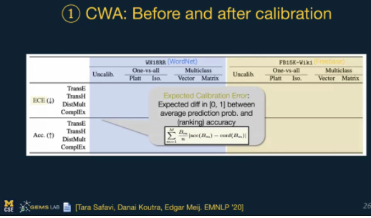

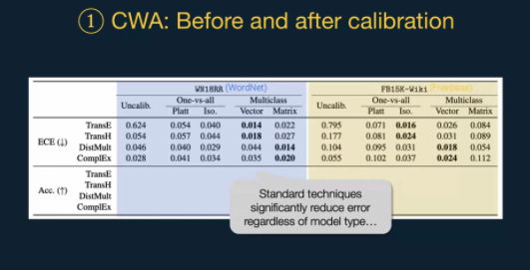

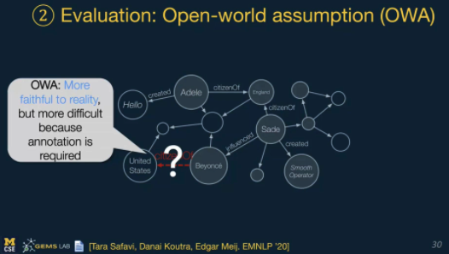

OWA: Unseen nodes are unknown; Closer to reality but requires annotation

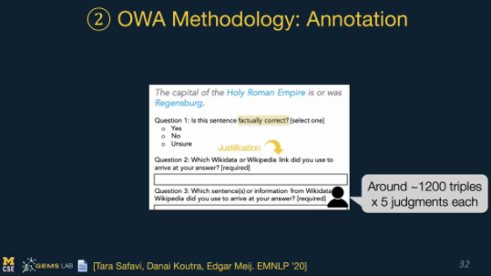

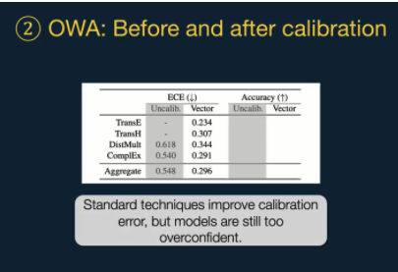

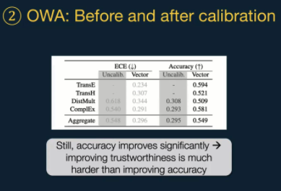

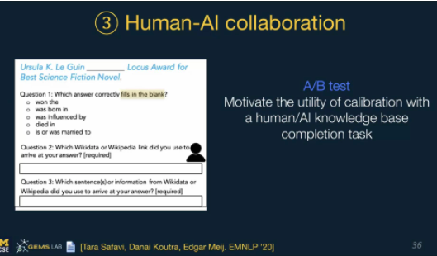

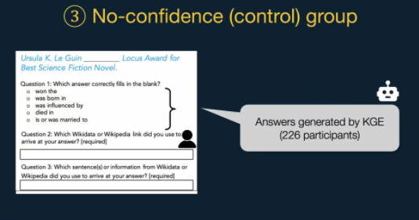

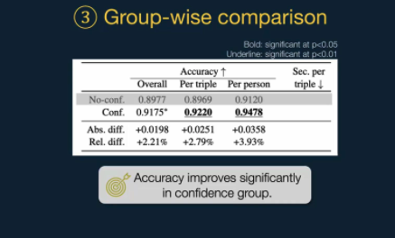

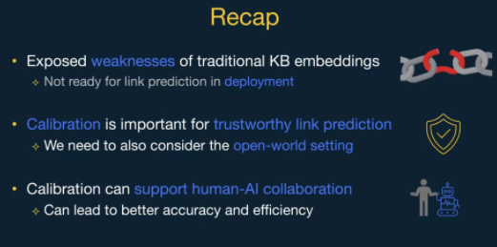

## CodeX benchmark

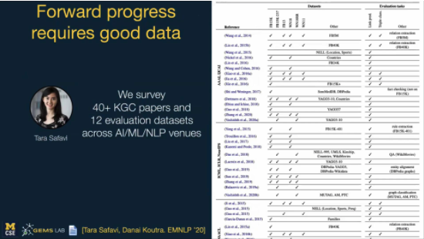

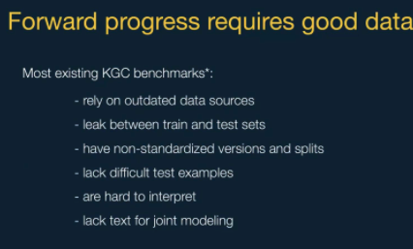



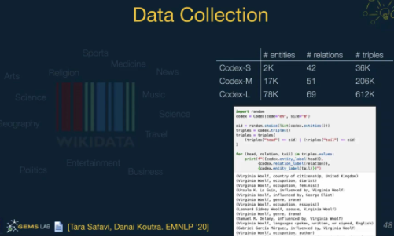

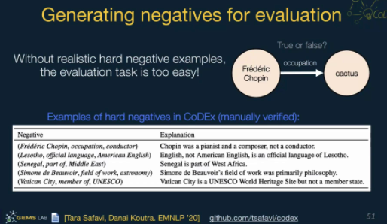

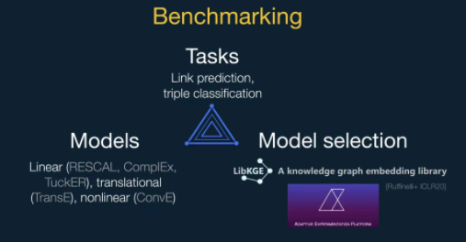

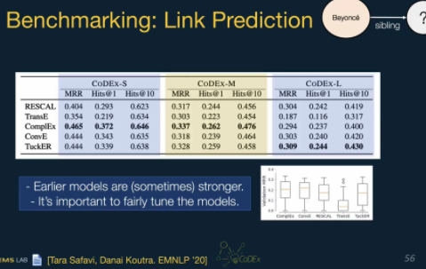

Use Cross Entropy

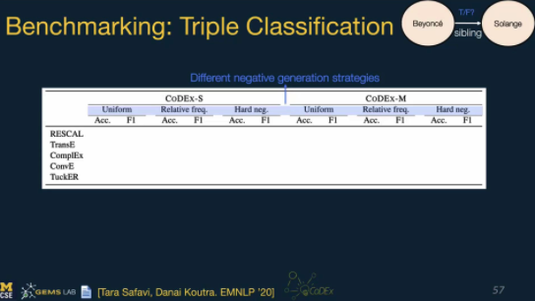

## Complemtary task: Locating Missing Information

**Research Paper:**

Recommender System D: 2:30PM - 4PM, TU (A32)

Finance| Misinformation and Integirty; 2:30PM-4PM, Tu (A26)

# 

# 